Narrative P3 EE 333

* Made corrections to P2
* Created hholmes1-P3 (New File Dialog)

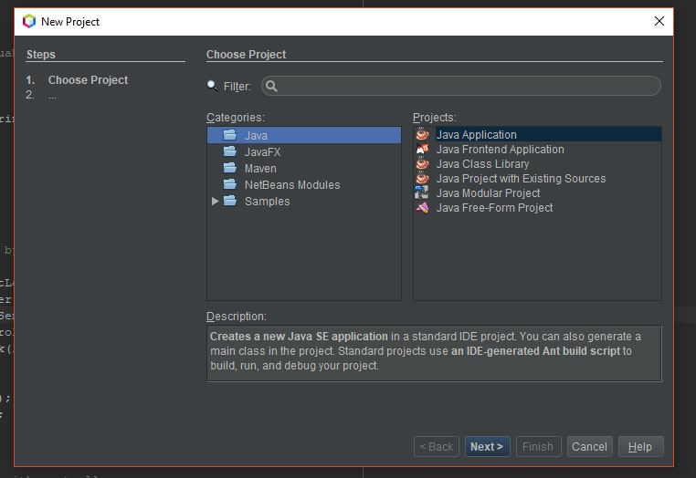

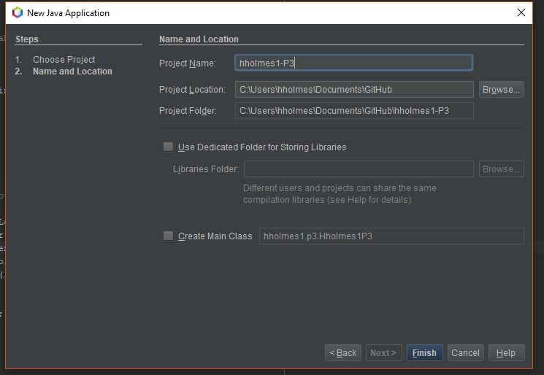

* Moved .java files from P2 to P3 Source files and Test files. Required refactoring files. Renamed TestP2 to TestP3

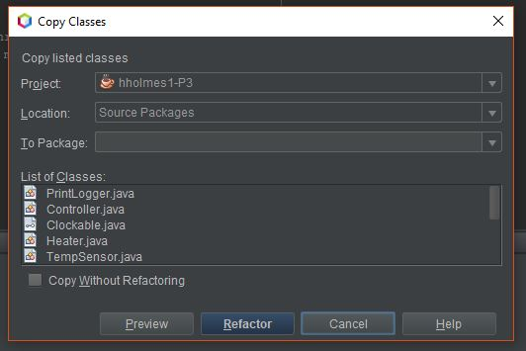

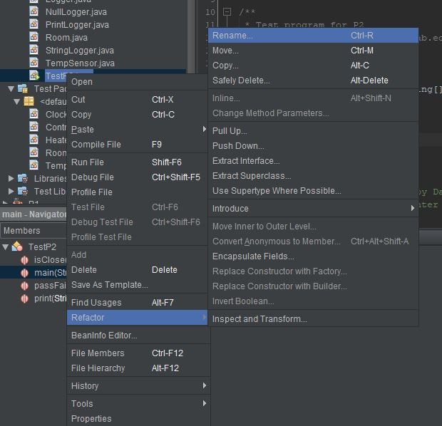

* Re-ran unit tests from P2 to verify that files still work after moving to P3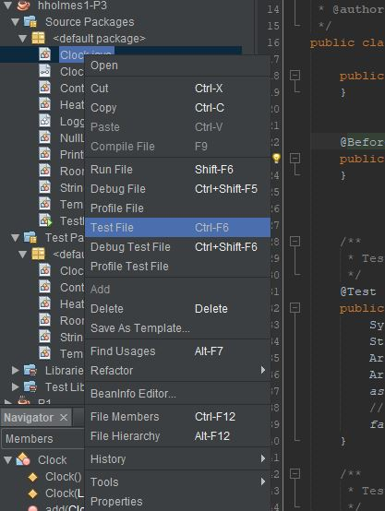

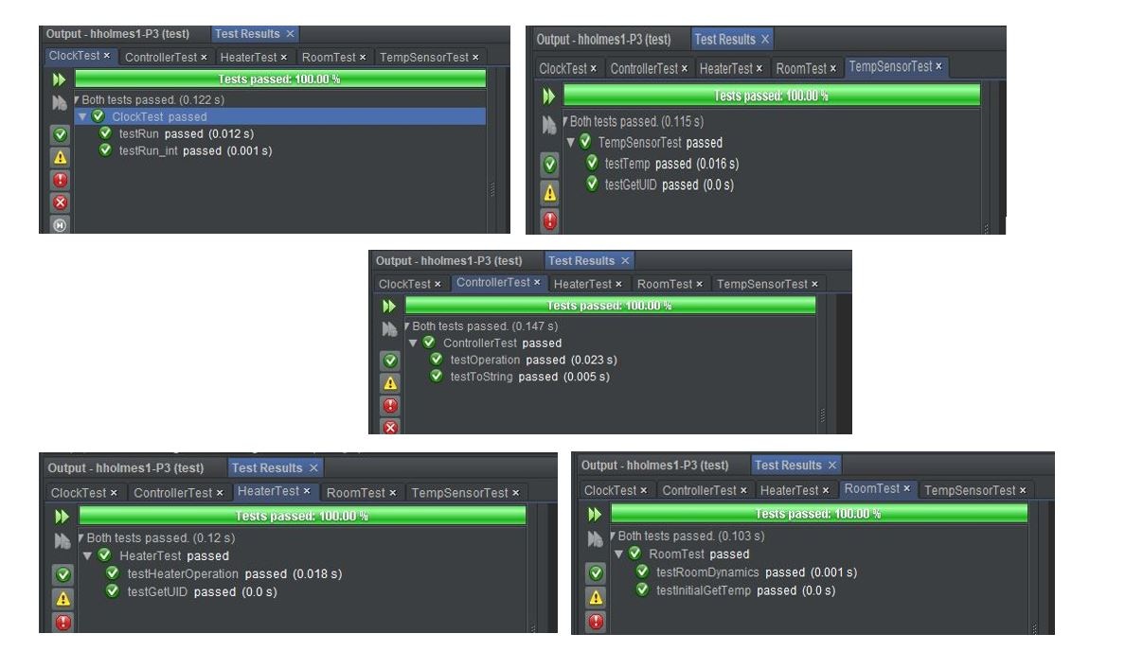

* Create Blower.java class

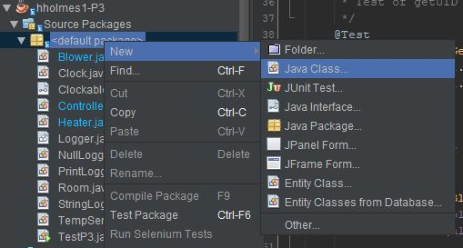

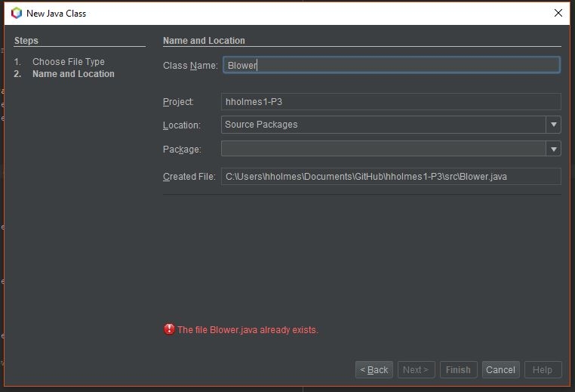

* + Very similar to code for heater
  + Created an “add” method to add a heater to a blower
  + Both heater and blower states need to be set by the controller but the blower should only run if the heater is running
  + Blower outputs air at 95 degrees when heater is on
* Ran TestP3 with new blower/heater configuration, encountered NullPointerException

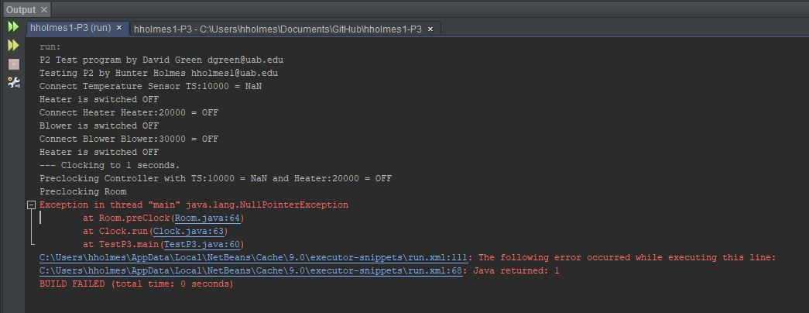

* + Clicking on “Room.java:64” took me to the line that could not be compiled
  + Recognizing this line as a problem, I selected it as a breakpoint for the debugger

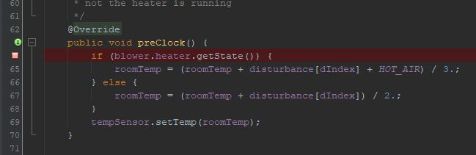

* + Was able to see that variable “blower.heater” was null by running the debugger

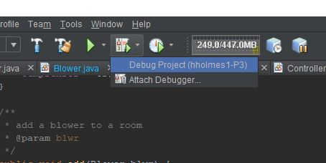

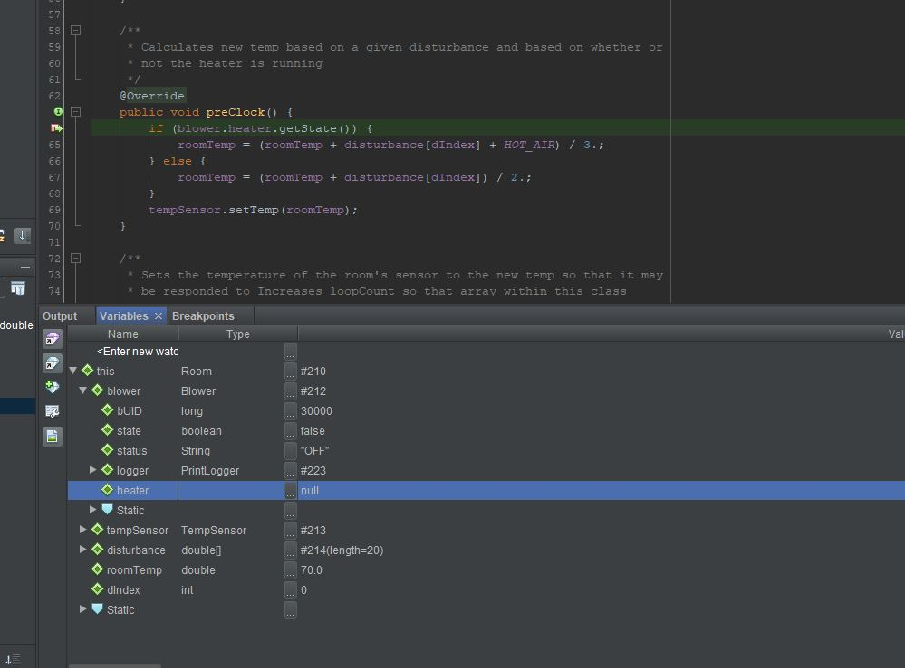

* + blower.heater was not initialized because I had not modified TestP3 to add a heater to the blower
  + Added “b1.add(h1)” to TestP3 and resolved issue
* Updated ControllerTest.java
  + Updated testToString() to look for proper Blower description
  + Also updated Controller to create proper Blower description
  + Added test make sure that blower status is dependent on heater status
* Created BlowerTest.java
  + Checks for proper UID assignment
  + Tests that blower can only be on when heater is on
  + Tests Blower’s toString as it relates to the state of the blower
* Added MissingComponentException.java
  + Creation done by simply creating class named MissingComponentException
  + Extends Exception
* Added “throws MissingComponentException” to preClock() in Clockable.java
  + Also added it to preClock() implementation in Controller.java
* Added conditional logic to Controller’s preClock to display message if a component is missing
* Added “throws MissingComponentException” to run methods in Clock.java
* Updated all Methods that call run(), run(int), and clock() to throw MissingComponentException
* Updated ControllerTest.java and ClockTest.java to throw MissingComponentException
* Updated Room.java
  + Now a blower is added to a room instead of a heater
    - Heater is now added to the blower
  + If blower is on, then Room accepts Blower’s output temperature for calculation
  + If blower is off, then temperature is based on current room temp and disturbance array
  + Room could accept a hot or cold input. Increases flexibility
* Updated RoomTest.java
  + Now tests for a situation with the blower off and the heater turning off and on
  + Had to create a new array for expected temp with blower off
* Update ControllerTest.java
  + Added tests to verify MissingComponentException
  + One test to verify that no exception is thrown if all components are connected
  + Three tests to verify that the correct message is displayed when attempting to preClock a controller that is missing a particular component
* Reran Unit Tests
  + Learned that I can run all tests at once if I right click on the project and click “test”
  + StringLoggerTest failed as it is not complete at this time
  + All other tests that have been created and updated for P3 passed

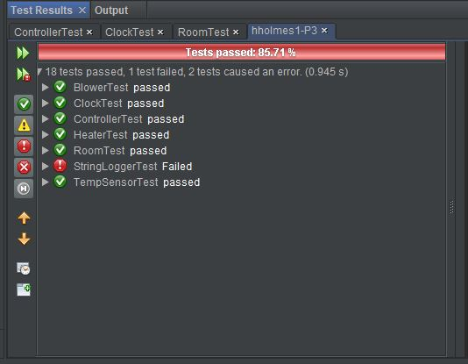

* Generated JavaDoc for hholmes-P3

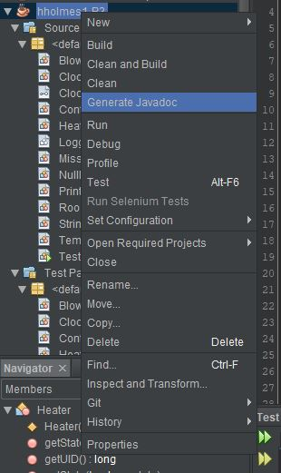

* + JavaDoc generation tool revealed various errors including bad characters, non-existent parameters, and parameters that were not denoted with a @param
  + Since the error messages indicated the lines I was able to fix the errors and some warnings